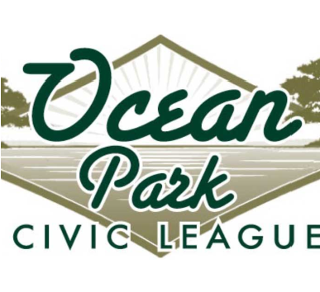
JOIN OPCL
opcl.org Mail this form & check to: OPCL P.O. BOX 55385 Virginia Beach VA 23471
Entire Household $25/calendar year (Jan-Dec)
Please print clearly
Name: ________________________________________________________________________________
Ocean Park Property Address: ________________________________________________________
________________________________________________________________________________________
If you do not reside in the property please provide your full mailing address:
Address: _______________________________________________________________________________
City, State & Zip:_____________________________________ _________________________________
Email Address: _______________________________________________________________________
Phone: (home)______________________________ (cell)_____________________________________
Volunteer too! Please circle your interests below:
Membership

Website

Adopt-A-
Spot

Newsletter

Advertising

Government
Affairs

Scholarship

Social

Finance

Fireworks

